DEXA Scanning

What is a DEXA Scan?

A DEXA Scan uses X ray equipment to measure bone density

What is a DEXA Scan used for?

DEXA Scans can assist in looking for signs of fragile bones (Osteoporosis), the risk of developing fractures and any diseases associated with low bone mass. If a patient does have Osteoporosis a DEXA Scan can also be used to monitor developments in the condition and effects of treatment.

Preparation for a DEXA Scan




There is no preparation required for a DEXA Scan. Patients should wear comfortable clothing with no metal fasteners or other metal parts such as an underwire bra. If patients think they may be pregnant they should not attend for the DEXA but should advise the Imaging Department so that later appointment can be booked.

What happens during a DEXA Scan?

The Radiographer will explain the process and answer any questions patients may have about the scan.

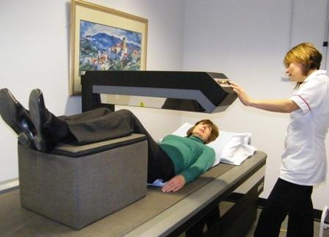

Patients are asked to lie face up on a couch and the scanning arm passes over the body sending X-Rays through the bones being tested, usually the hip and lower spine. The scanner is not a tunnel. The Radiographer remains with the patient while the scanning is taking place which takes about 15 minutes. There is no contact with the scanner and patients do not feel anything.
After the Scan

After the scan and patients can eat and drink normally and will be able to drive home. Patients will not receive their results on the day of the scan. A Consultant will provide a report to the doctor who requested the scan. The report is available usually within 2 weeks.

The Risks

DEXA Scanning is very safe but it does use a small amount of radiation. Patients who have queries about the procedure should speak to the radiographer before the scan.

