Constipation and IBD

Patient Information Sheet

What is constipation?

Constipation is a symptom not a disease. The word “constipated” can mean different things to different people. It can be a feeling that the stools are too hard or that the bowels do not empty regularly or easily enough. For most people it is not harmful to be constipated.

In Western society constipation probably occurs more than in other cultures – one in six people. It is estimated that as many as one young woman in every 12 suffers with constipation, mainly in their late teens to 20s. It is also more common in older people. Very occasionally there is a disease underlying the constipation, but most of the time the disturbance in bowel habit is not due to an abnormality of the colon (a structural problem) but is rather a functional problem (one due to a disturbance of how the bowel contracts or empties).
Bowel cancer is an uncommon cause of constipation. It is important to remember that even in patients who suffer with constipation over many years, there is no associated increased risk of bowel cancer.

Normal bowel function




Frequency of bowel movements varies widely in the general population. It is actually normal to pass stools between three times a day and once every three days. Most adults take bowel control for granted and give it little thought. However, bowel control is actually a complex and incompletely understood process, involving delicate co-ordination of many different nerves and muscles. The bowel is part of the digestive system and its role is to digest the food that we eat, absorb the goodness and nutrients from the digested food into the blood stream and then to process and expel the waste products from the food that the body cannot use. This process starts at the mouth and finishes at the anus.

The small bowel (or small intestine) is the power-house; the part of the bowel that does the bilk of the food and fluid absorption. The small bowel delivers 1-2 pints (500-1,000mls) of waste to the colon per day. The colon, or large bowel, is the waste processing part of the system (Figure 1). This waste is the consistency of thick pea soup when it enters the beginning of the colon. It is the job of the colon to absorb fluid from this waste and, as it moves around the colon, to gradually form it into stools (also called faeces or bowel motions). Stool consistency can vary between hard lumps to very loose or mushy faeces, often depending how long the stool has been in the colon and how much water has been absorbed from them. Ideally stools should be formed into soft smooth sausage-shapes to make it easier to pass.

Figure 1: The large bowel

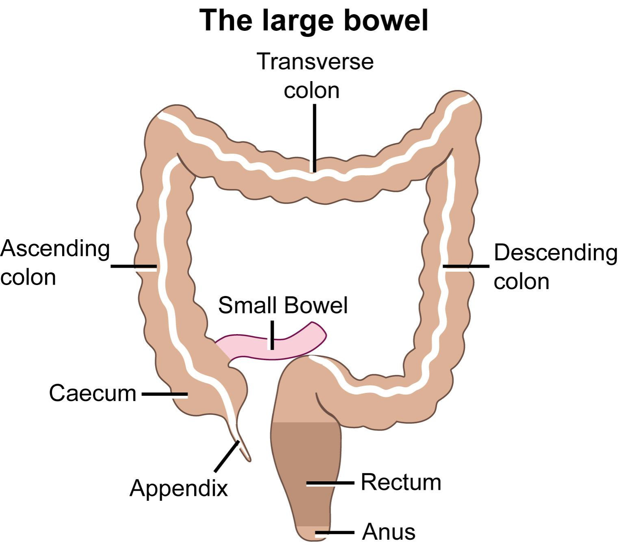

The left side of the colon and the rectum are the "storage tank" at the end of the large bowel. Some stool enters the rectum fairly regularly, but most arrives as a result of mass movements, which happens approximately 6x a day and can be associated with the urge to go to the toilet. These mass movements are major waves of pressure (peristalsis), which can move stools through the whole length of the colon, like toothpaste being squeezed along a tube. Often a large part of the contents of the colon arrives in the rectum at once.

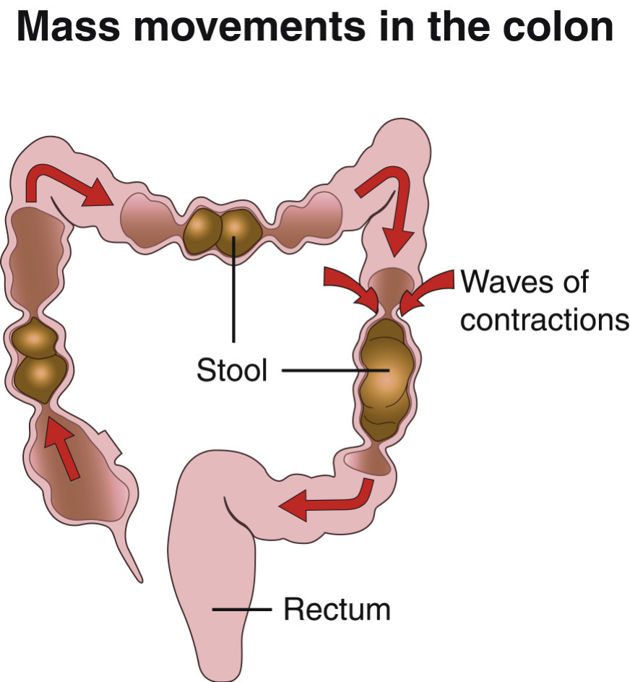

These mass movements are often triggered by the gastro-colic response. Food arriving in the stomach when you eat a meal sets off a pressure wave in the colon some minutes later. This can lead to a need to empty the bowels, sometimes urgently, soon after eating.

For many people the bowel is relatively quiet at night. The first meal of the day, together with the physical activity involved in getting out of bed and washing and dressing, stimulates contractions in the colon and mass movements. This leads to an “urge”, the feeling that the bowel need to be emptied, shortly after breakfast. Food usually takes an average of one to three days to be processed and up to 90 per cent of that time is spent in the colon.

How often should I empty my bowels?

There is no right or wrong answer to this. There is a very wide range of “normal” bowel function between different people. Less than 30% of the British population achieve the “Holy Grail” of toileting; the once a day achievement. It is by no means essential to have one bowel action per day. Some people always go several times per day; others have several days between bowel actions.

Perception of what is normal is based on personal experiences and growing up with other people. Most of us do not discuss bowel habit with our friends, or even our family. A few people become obsessed with the need for a daily bowel action and spend excessive amounts of time in the toilet or take laxatives to achieve this. Often this is unnecessary.

Normal bowel emptying

When a stool enters the rectum, the internal anal sphincter muscle automatically relaxes and opens up the top of the anal canal. This is normal and allows the stool to enter the upper anal canal to be “sampled” by the very sensitive nerve cells in the upper anal canal (Figure 3). People with normal sensation can easily tell the difference between wind (gas, also called flatus, which can safely be passed if it is socially convenient without fear of soiling), diarrhoea (very loose or runny stools needing urgent attention and access to a toilet) and a normal stool. Most people just know that stool is in the rectum without really having to think about it.

Figure 3: Internal sphincter relaxation when the rectum is full

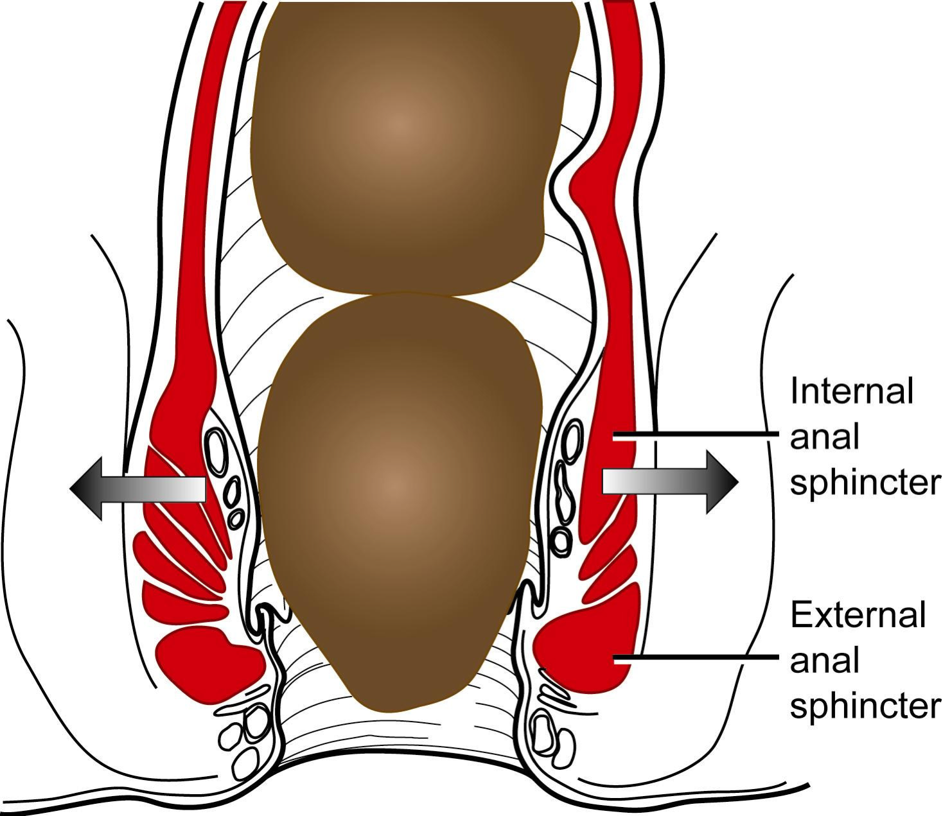

Around the internal anal sphincter is the external anal sphincter, which is much thicker. This is the muscle around the anus that you can deliberately squeeze. Just like the muscles in the arm or leg, a person can decide when to use this muscle. If a normal stool is sensed and it is not convenient to find a toilet at that moment, bowel emptying is delayed by squeezing the external anal sphincter. Squeezing the external sphincter ensures that the stool is not simply expelled as soon as it enters the rectum, and in fact the stool is pushed back up out of the anal canal (Figure 4). For most people this is not a deliberate action - you should not need to think, “I must squeeze my anal sphincter muscles so that I do not have a bowel action” - but this is actually what you do, without realising it.

Figure 4: Delaying bowel emptying

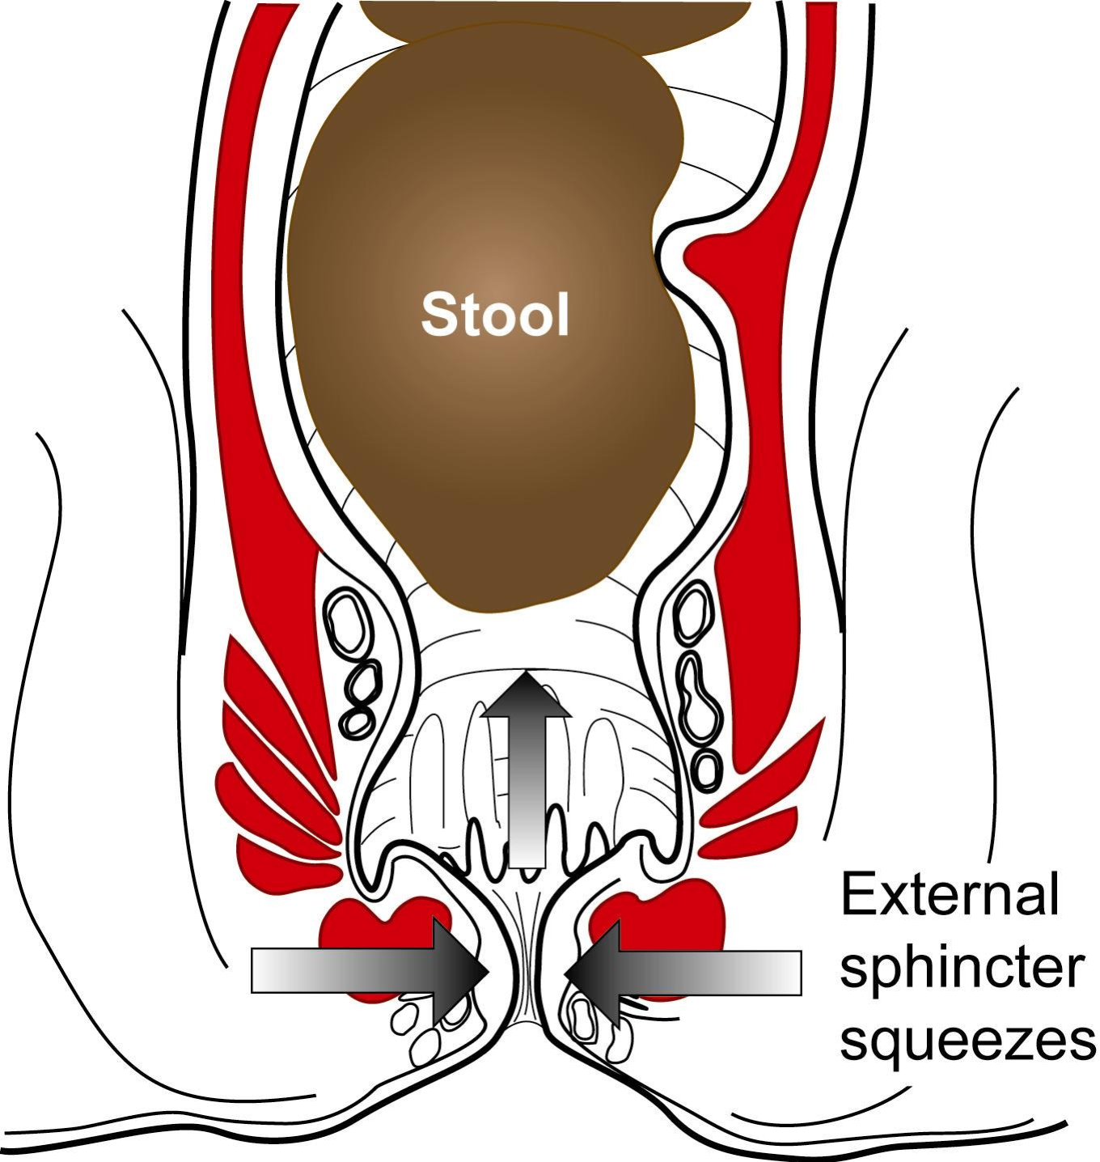
This external sphincter squeeze does not need to last all the time until the toilet is found. Stools are propelled back into the rectum, and the rectum relaxes and so the urge to empty the bowel is resisted and wears off.

For most people, an urge to empty the bowel is felt, but if the time and place are not right, it is possible to delay bowel emptying, and the feeling of needing to go wears off very soon. Most people can then forget about the bowel for a while, and some can put off bowel emptying almost indefinitely, but may get reminders that the bowel is full at intervals until it is emptied. Continually resisting the urge to empty the bowel or ignoring “the call to pass a stool” can lead to longterm constipation and motility problems, and the longer the stools stay in the colon and rectum, the more fluid is absorbed and the harder the stools become.

As you can imagine, this is a delicate system and unfortunately there are many things that can go wrong with it.

Complications of constipation

A large number of patients with constipation get abdominal bloating and discomfort. Patients often complain of tiredness and fatigue, although there is no clear evidence of anaemia or build up of supposed gut “toxins”. Pain and vomiting are rarer complaints.

It very uncommon for the young and fit to get serious complications from
constipation. However elderly or malnourished people may develop problems including;

- Faecal impaction – this is a condition in which a solid ball of stool builds up in the rectum. This can present with diarrhoea as only liquid stool can make its way past the obstructing stool. It is most often seen in people who are unable to move around easily and those who are taking lots of medications.

- Stool perforation – this is an exceptionally rare condition where a hard stool sits in the colon for so long that it wears through the wall and surgery becomes necessary.

- Rectal prolapse – this means that the rectum comes down and can hang out of the (anus) back passage. This can occur as a complication of straining on constipation or of generally weak pelvic floor muscles, either due to advanced years or malnutrition.

There are many who believe that haemorrhoids (piles) are a complication of
constipation. However, haemorrhoids are more common in young men than young women and constipation is less common in men. It is true however that sitting on the toilet for long periods of time can aggravate haemorrhoids.

What investigations are needed for constipation?

The decision to do various investigations will be based on factors such as
symptoms, family history and age. Investigations may include;-

Colonic investigations: Your doctor may decide to look at your colon or part of your colon to see if there is a cause for your symptoms on the bowel lining. These may include a flexible sigmoidoscopy or colonoscopy or more rarely a barium enema. These tests are generally extremely safe, with only a very small risk of damage to your bowel.
Anorectal physiological testing: This test takes about 15 minutes and looks at the way the muscles and nerves of the rectum and anus are working.
Transit studies: This test gives a measure of whether or not the passage of food through the gut (colon) is slow or normal. You must stop your laxatives,
suppositories and enemas for the duration of this test. Your doctor will also want to know how many times you open your bowels during the test time, so you will need to keep a record of this. The test itself is simple – you will be asked to swallow some capsules (containing tiny “markers” that show up on x-ray) and then have an x-ray of your abdomen a few days later. The distribution of the markers in your colon shows whether your bowel transit is normal or slow. Normal transit of contents from the mouth to the anus is usually less than 72 hours for the majority of patients.
Dynamic MRI defaecography: This is a sophisticated test which avoids exposure to x-rays. A jelly is inserted into the rectum and then images are taken. These show the structure of the rectum in relation to the pelvic floor and the surrounding organs. Studies are performed at rest and then as you bear down.
Defaecating proctography: This involves insertion of a paste into the rectum, with x-rays being taken whilst the paste is passed from the rectum. The test shows the shape of the rectum and how it empties, including the presence of a rectocoele or rectal prolapse.

What treatments are available?

1. Lifestyle
It is important to try to make time for your bowels each day. Most bowels respond best to a regular habit. About 30 minutes after eating is the most likely time for the bowel to work. This is because of the “gastro-colic response” which means that eating sets waves of activity in motion in the bowel. Try not to rush going to the toilet. If you have a tendency to be constipated, set aside about 10 minutes in the toilet. Preferably this should be at a time when you are not rushing to do other things. Find a toilet that you feel comfortable to use and where you do not feel inhibited by lack of privacy or time. Sport and exercise improve bowel habits in some people. If you lead a very inactive lifestyle (driving to work at a desk job) even taking a regular walk at lunchtime can make a difference. You can also try your own toilet exercises if you want to avoid a formal retraining program supervised by a therapist

2. Diet and fluids
Eating regularly is the best stimulant for your bowels. Skipping meals, especially breakfast, can lead to a sluggish or irregular bowel habit. Contrary to popular belief a high fibre diet is not always the best diet for the constipation sufferer. Regular meals and an adequate fluid intake are the main aims. Too much fibre can lead to an increase in bloating and discomfort, especially for people with slow gut transit. If you do feel your diet is short on fibre try to use fruit and vegetables (soluble fibre) rather than cereals (insoluble fibre) as they cause less bloating. Some foods can act as natural laxatives in some people (eg. prunes, apricots, chocolate).

Try to drink at least 2L (eight to10 mugs) of fluid a day. However, excessive fluid intake may make you feel more bloated and is unlikely to improve your bowel function further. Too much caffeine (coffee, tea and cola) can be dehydrating, as can too much alcohol.

3. Medications
If you are taking any medicines (prescribed or bought from the chemist) ask your doctor or chemist if they could be adding to your constipation. If possible, try to remove constipating medications.
If really necessary, some patients find benefit from being started on a soluble fibre supplement such as Movicol. Suppositories and / or mini-enemas can be used to help regulate the bowel habits. It is best to only use these as an aid to getting into a regular routine, rather than relying on them longterm.

a) Laxatives

The use of regular laxatives should usually be confined to people who;-
- suffer from regular constipation.
- need something to counteract short-term constipating medication.
- need to avoid straining (e.g. angina sufferers)
- are hospitalised
- have anal conditions requiring soft stools to allow for the healing period.
- undergo a radiological or surgical procedure.
- who are severely or terminally ill.

It is common for patients to come to clinic and say: “I tried this laxative and it worked well to start with but then it stopped working so well.” They try another and another and another and it’s the same story every time. The nature of long-term laxative use is that either the bowel becomes progressively less responsive to all these agents, or that patients expectations about their desired bowel frequency changes. There is no convincing evidence that the colon is permanently damaged by long term laxative use, and in particular there is no increased risk of bowel cancer caused by laxatives.

Nevertheless, these are not drugs that should be considered harmless. Some laxatives stain the insides of the bowel (melanosis coli) and this can be seen at colonoscopy (examination of the lining of the colon). The fact that a product is “natural” (eg. Senna leaf) does not necessarily mean that it is “good for you”. Laxatives can cause significant loss of minerals from the bowel, and uncontrolled long-term use can result in changes in the body’s chemistry, especially in older people and those who are unwell. The more you take laxatives, the less likely it is that the bowel will work on its own. This does not mean that you cannot stop taking laxatives once you have started, but it can take a while for the bowel to start working on its own again.

b) Suppositories or mini-enemas

Whilst the idea of inserting a suppository or enema may not appeal to all, it is
important to bear in mind a number of advantages;-
- Their action is more predictable than that of laxatives, without the tendency to cause diarrhoea.
- They can encourage a more regular bowel action especially if taken at the same time of day (every day, every other day or once every three days).
- They are generally well-tolerated. They are acting locally just like a nasal spray taken for hayfever or inhalers for asthma. Since there is minimal absorption into the body, there is low potential for side-effects. They must be inserted into the rectum for maximum effect. You can get a supply of gloves from your chemist. Suppositories and enemas work by causing contraction of the rectum, softening the stool in the rectum and by causing the bowel higher up to contract.

Ideas to ensure that you have the best chance of passing a stool

- Try to go to the toilet at a regular time or times every day. This may follow breakfast or a coffee.
- Take your time. Try to ensure that you will have about 10 minutes without interruption.
- Firstly make sure you are comfortable on the toilet. It is most natural for
humans to squat to pass a stool. You may find that having your feet on a footstool about 20-30 cm (8-10 inches) high helps by improving the angle of the rectum within the pelvis, making it easier to pass stools. Keep your feet about 1.5 - 2 feet apart.
- Relax and breathe normally. Do not hold your breath as this will encourage you to strain.
- Using your abdominal muscles effectively is best done with one hand on your lower abdomen, and one on your waist. As your abdominal muscles tighten you should feel your hands being pushed out forwards and sideways. This is called ‘brace’ or ‘brace and bulge’.
- Concentrate on relaxing the anus to allow the stool to pass. Do not push from above without relaxing the anus below.
- Do not adopt any “weird and wonderful” positions – this will not help you in the long-term.
- Do not spend endless time on the toilet straining. If the bowels do not open - DO NOT PANIC - try again at the same time the next day. It may not be normal for you to pass a stool every day.

